LET YOUR MOMMA GO 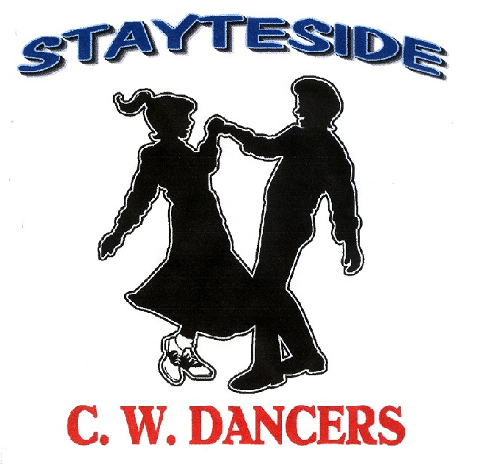

Description. Partner Dance. (40 counts) Opposite Footwork Throughout, Gents Steps Listed.
Start. Double Open Hand Hold. Face To Face.Gent: Facing OLOD, Lady: Facing ILOD.
Choreographer. Carol* & George Stayte (UK).*Fully Qualified D&G Instructor. 02392 423925.
carol.stayte@ntlworld.com
Music. “Let Your Momma Go” by Ann Tayler. CD Let Your Momma Go. (162bpm)
Alternative: “I’ll Be Turning To You” by Kieran Kane. CD Find My Way Home (156bpm)
“Except For Monday” by Lorrie Morgan CD Greatest Hits (172bpm)

Chasse, Rock, Recover, ¼ Turn, Pivot ½, Step Forward, Step, Lock, Step.
1 & 2 Left Chasse. LRL.
3 & 4 Gent: Rock right over left, recover on left, ¼ turn right stepping fwd on right.
Lady: Rock left behind right, recover on right, ¼ turn left stepping fwd on left.
(Release ladies left hand. RLOD)
5 & 6 Step fwd on left, pivot ½ turn right, step fwd on left.
(Release hands on turn then rejoin inside hands LOD)
7 & 8 Step fwd on right, lock left behind right, step fwd on right.

Side Rock Cross, Chasse, Mambo ½ Turn, Chasse.
1 & 2 Rock left to the side, recover on right, cross left over right.
3 & 4 Chasse. RLR.
(Gent moving behind lady to her right, release hands, rejoin inside hands)
5 & 6 Rock fwd on left, recover on right, ½ turn left stepping fwd on left.
(Release hands, rejoin inside hands RLOD)
7 & 8 Chasse. RLR.
(Gent moving behind lady to her right, release hands, rejoin inside hands)

Mambo ¼ Turn, Cross Shuffle, Chasse, Back Rock , ¼ Turn.
1 & 2 Rock fwd on left, recover on right, ¼ turn left stepping to side on left.
(Gent: Facing OLOD Lady: ILOD. Rejoin hands into double open hand hold)
3 & 4 Cross shuffle. RLR.
5 & 6 Chasse. LRL.
7 & 8 Rock back on right, recover on left, ¼ turn left, stepping back on right.
(Release ladies right hand LOD)

Coaster Step, Shuffle Forward, Mambo Forward, ½ Turn Shuffle.
1 & 2 Step back on left, together on right, step fwd on left.
3 & 4 Right shuffle fwd. RLR.
5 & 6 Rock fwd on left, recover on right, step back on left.
7 & 8 ½ Turn shuffle turning right. RLR. (Release hands RLOD)

½ Turn Shuffle, Mambo Back, Pivot ¼ Turn, Cross, Side Rock Cross.
1 & 2 ½ Turn shuffle turning right, LRL. (Rejoin inside hands LOD)
3 & 4 Rock back on right, together on left, step fwd on right.
5 & 6 Step fwd on left, Pivot ¼ turn right, step left across right.
(Gent: Facing OLOD. Lady: ILOD. Rejoin hands into double open hand hold)
7 & 8 Rock to the side on right, recover on left, cross right over left.

START AGAIN

